CMPE 277: SmartPhone App Development

## HW 02: Cloud Connected App

## Supriya Meduri (015262767)

Knewzz App :

**Summary** : Implemented the following features as a part of HW 2

1. Developed an android news app in JAVA via Retrofit, Moshi, binding.
2. Displayed news list view with a search bar and news detail view.
3. Implemented swipe refresh layout and splash screen for better UI and usability
4. Used Firebase Authentication for letting the users create account and login
5. Users can reset password after logging into the application and also can use the forgot password option.
6. Users can log out of the application as and when needed.

**App Demo Video:** <https://youtu.be/1mtUVPeLmhg>

**APP Screenshots:**

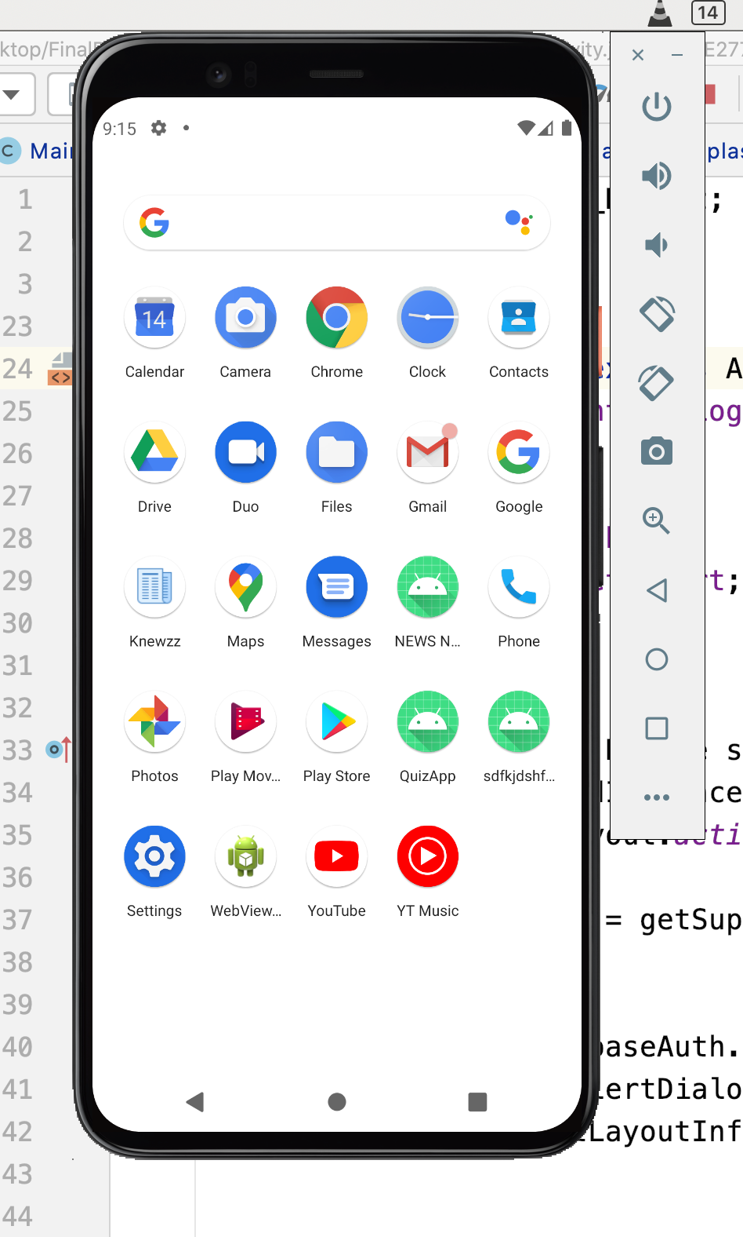

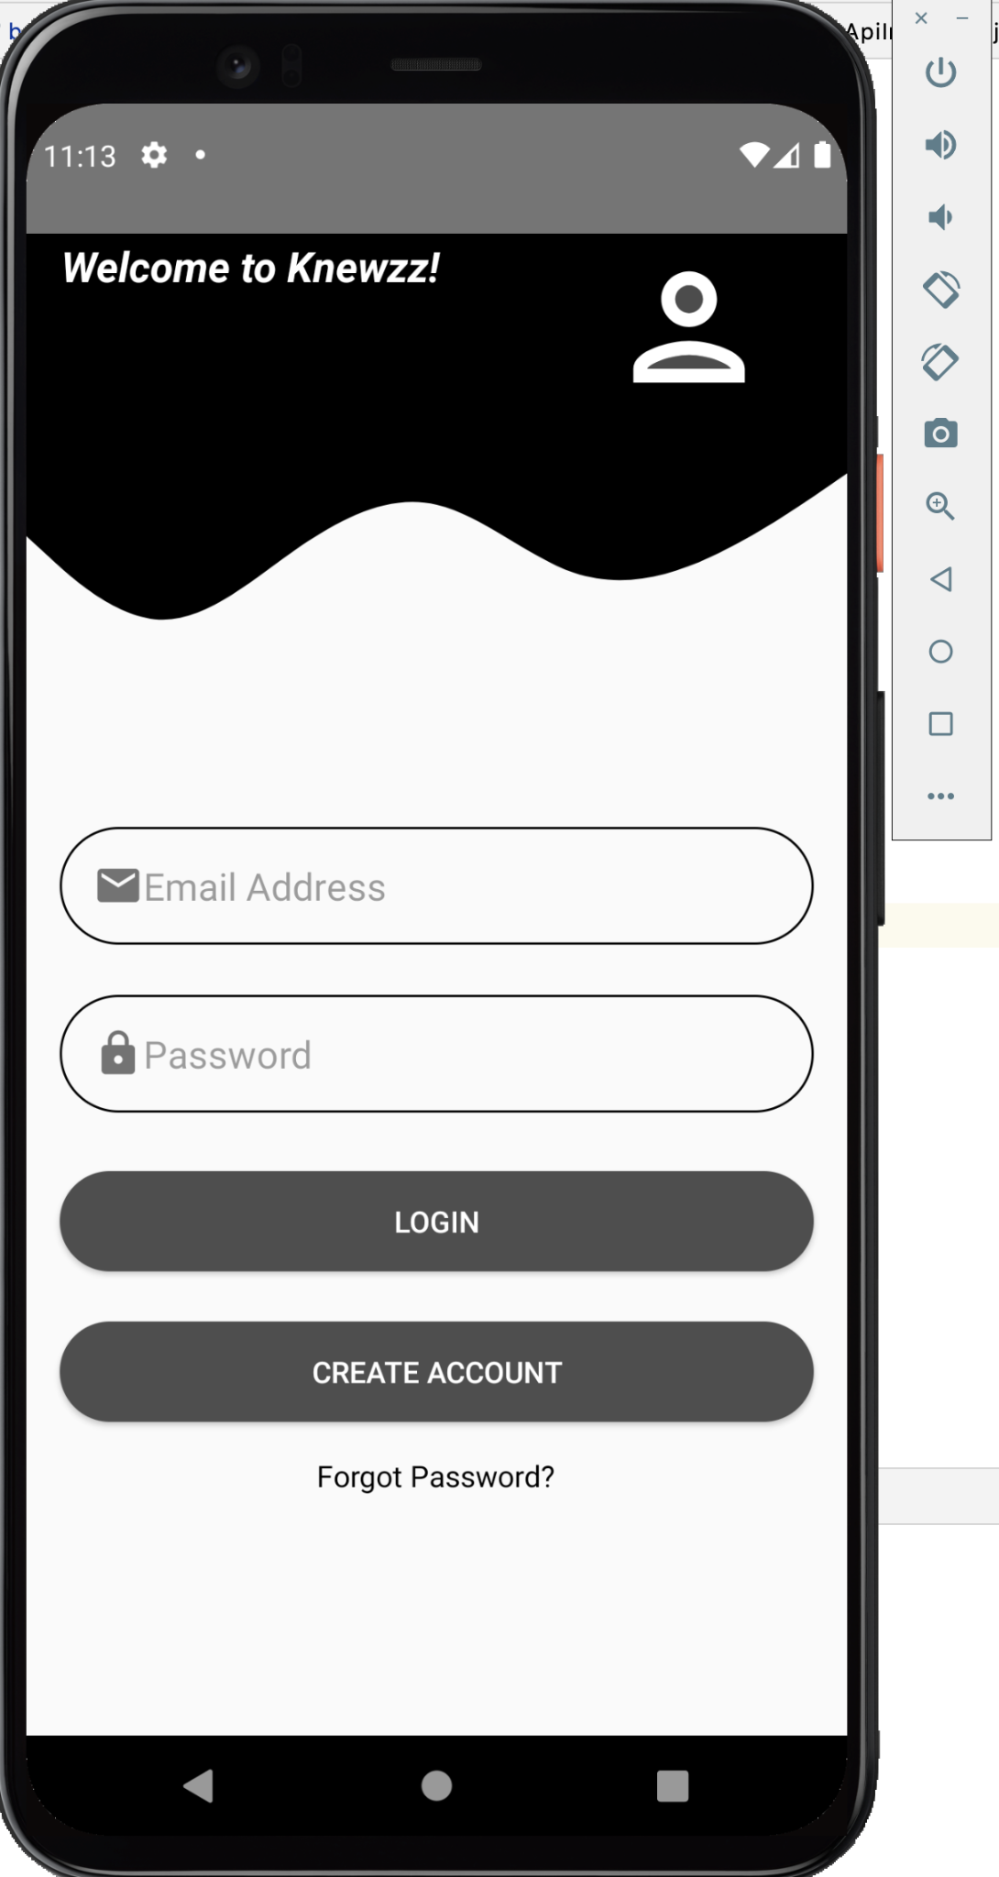

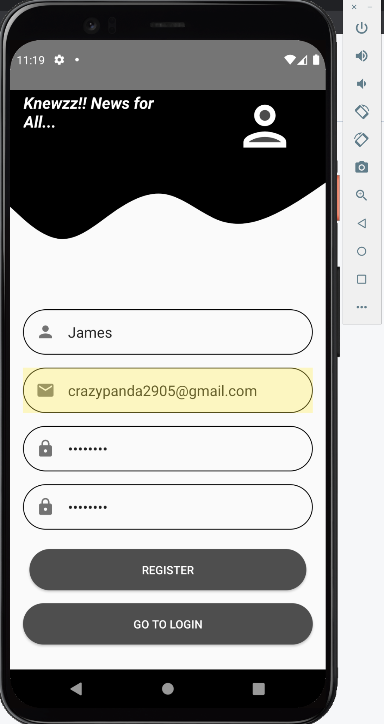

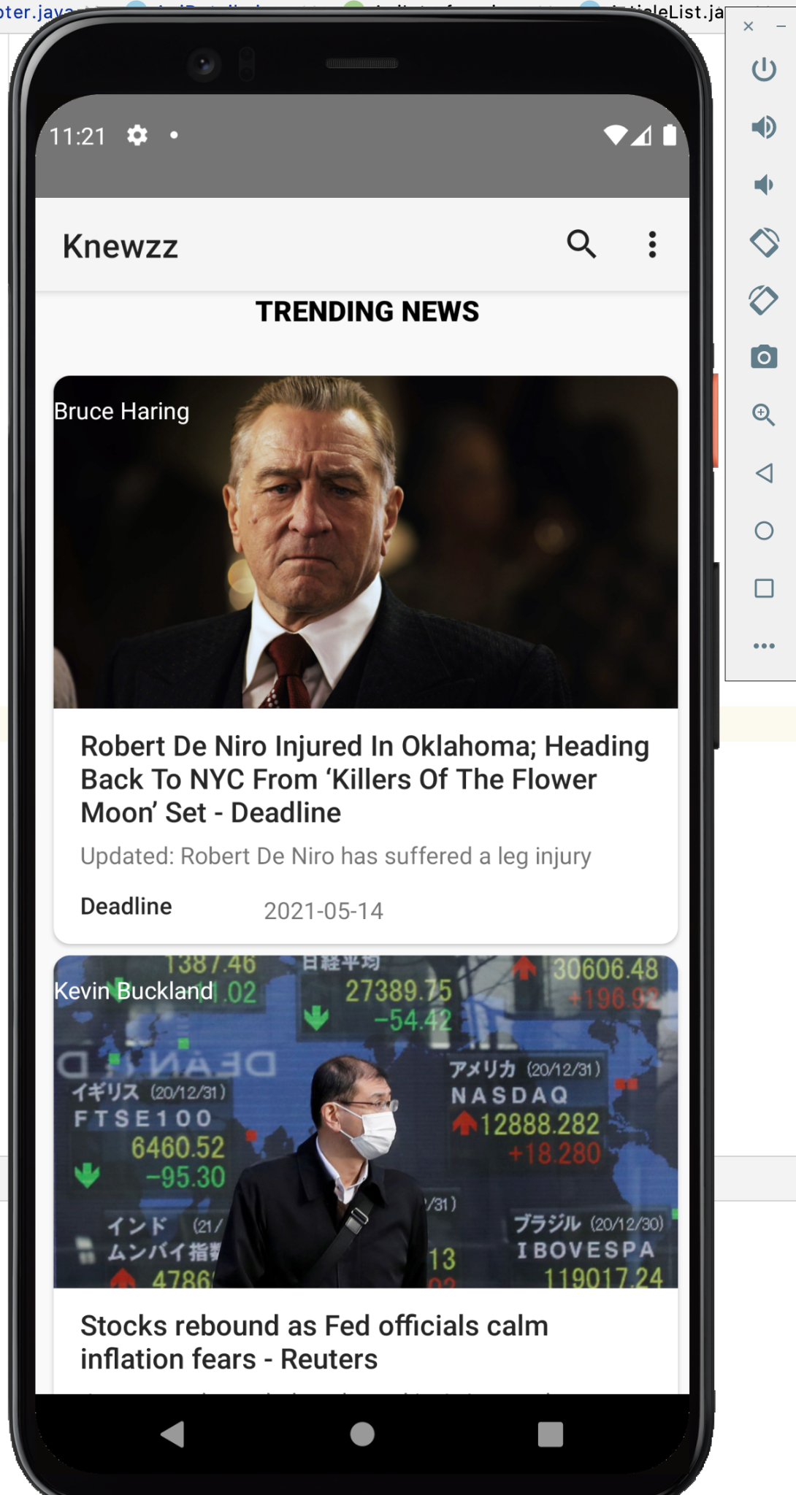

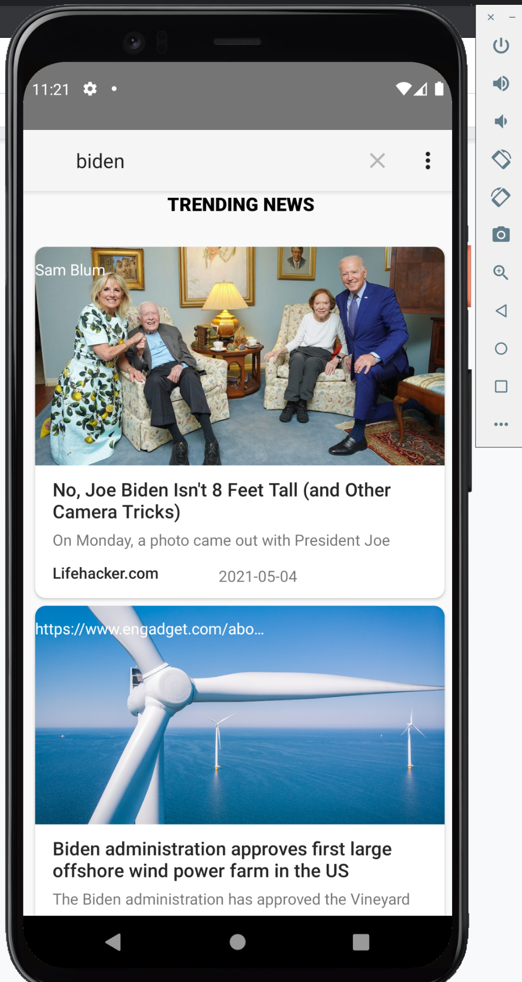

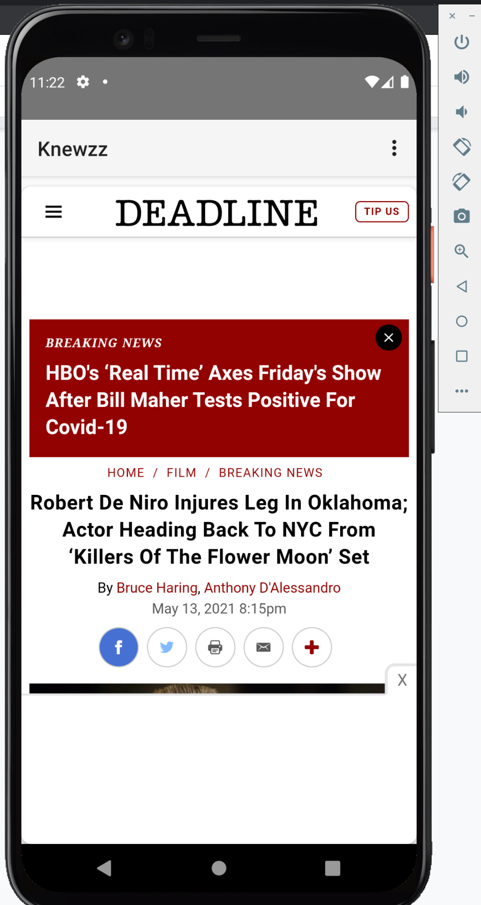

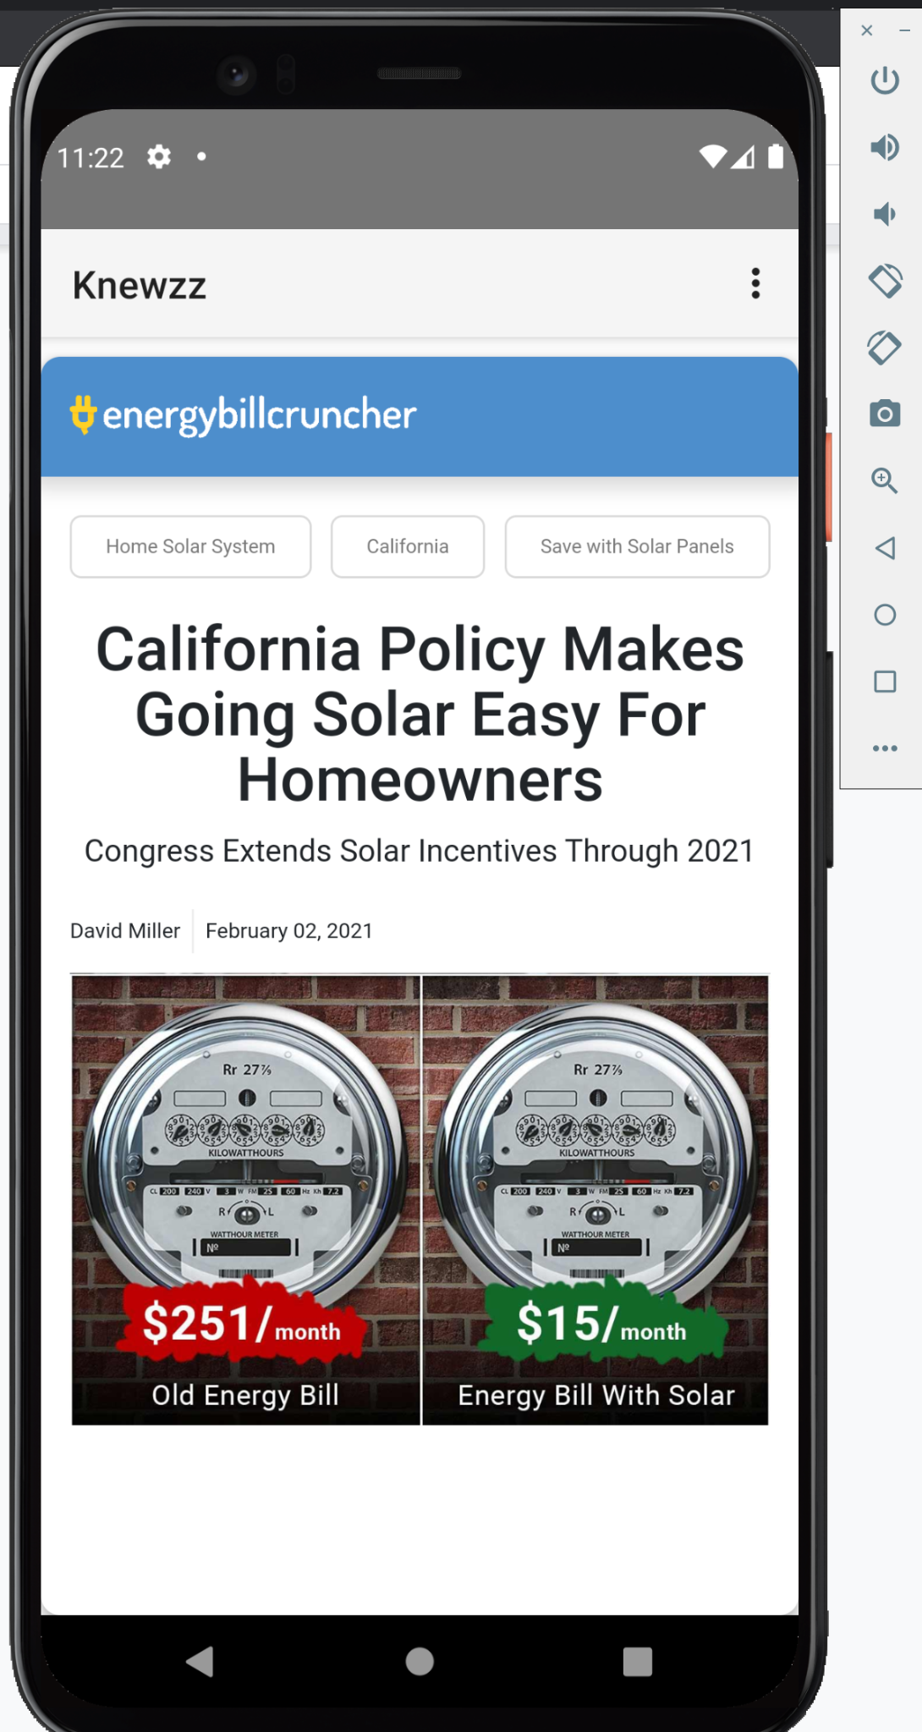

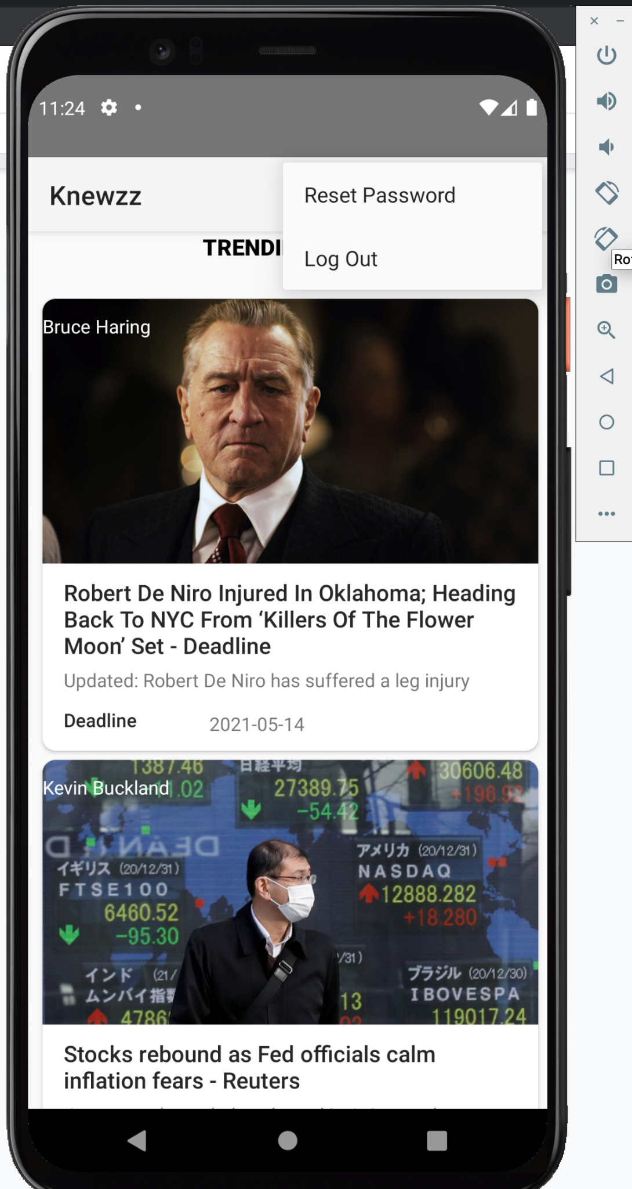

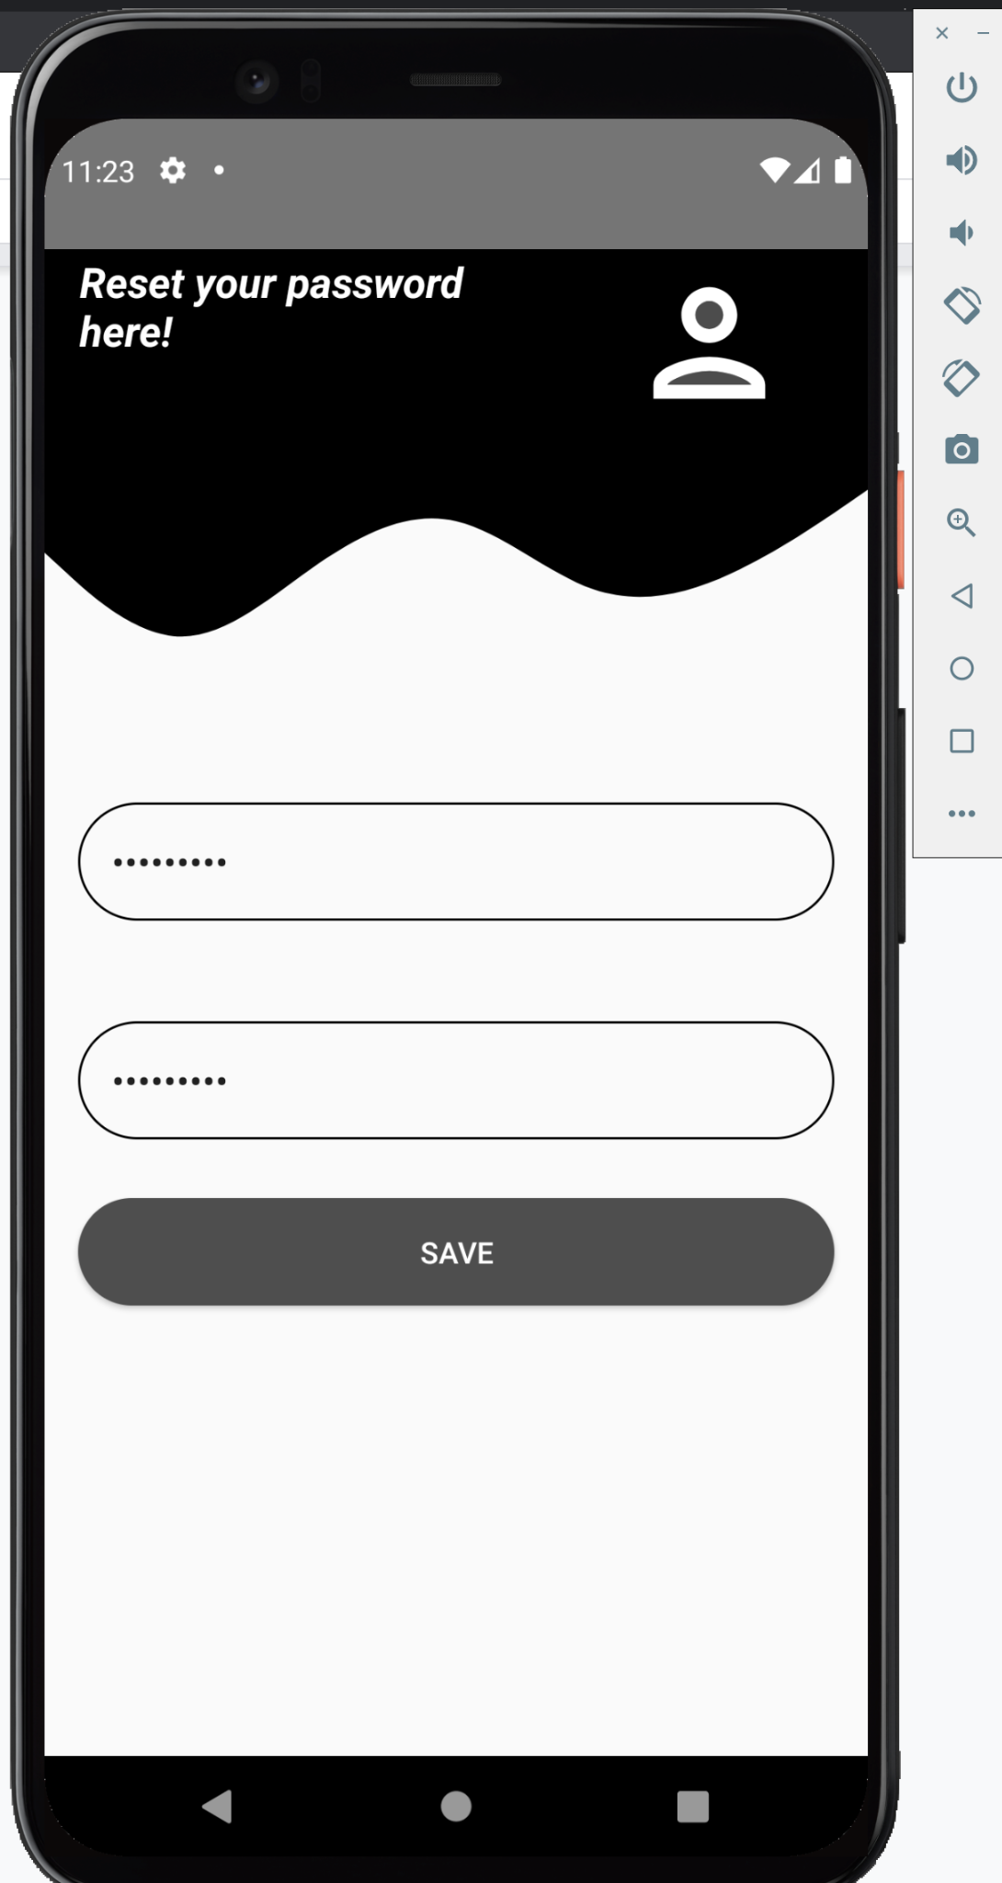

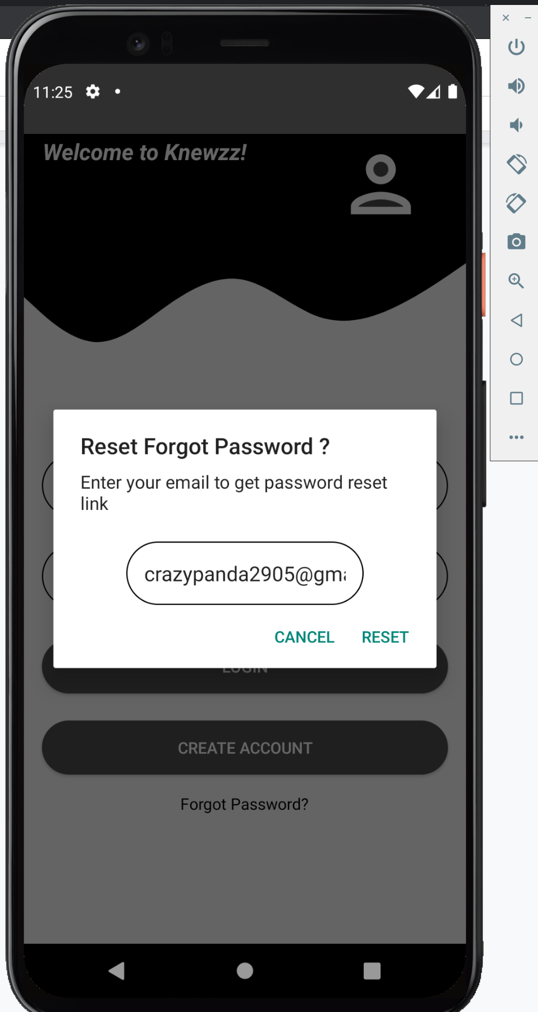

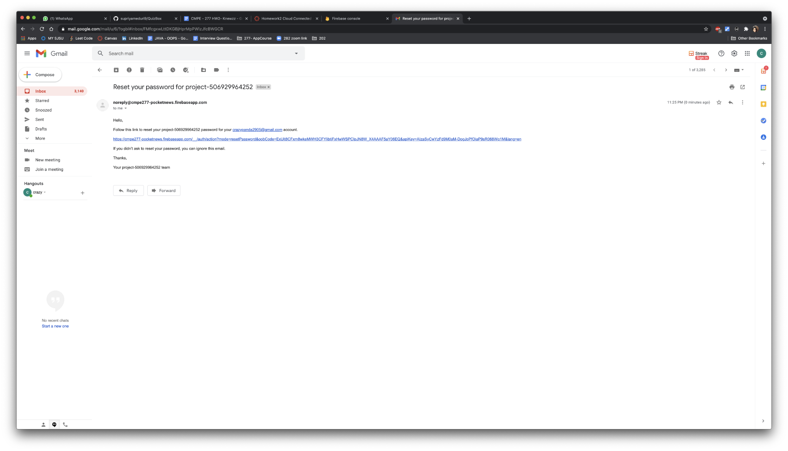

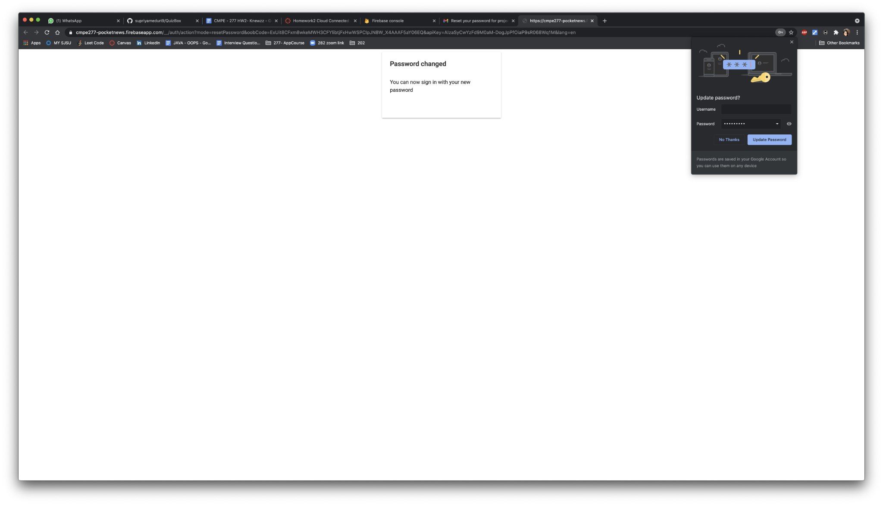

**Firebase Authentication:**

